A1_Problem3

library("gurobi")

## Loading required package: slam

library("Matrix")  
library("igraph")

##   
## Attaching package: 'igraph'

## The following objects are masked from 'package:stats':  
##   
## decompose, spectrum

## The following object is masked from 'package:base':  
##   
## union

library("rdist")  
  
K <- 4  
K

## [1] 4

C = 10  
Pmin = 10  
P = matrix(sample(0:30,K*C,replace = T), nrow=K, ncol=C, byrow=T)  
cvec = c(rep(1,each=K), rep(0,each=K*C))  
  
Amat = matrix(0, nrow=(K*C+K+C), ncol=(K+K*C))  
bvec = c(rep(0,each=K*C),rep(1,each=C),rep(0,each=K))  
dir = c(rep("<=",each=K*C),rep(">=",each=C+K))  
  
row = 1  
for(i in 1:C){  
 for(j in 1:K){  
 bvec[row] = P[j,i]  
 row = row + 1  
 }  
}  
  
for(i in 1:(K*C)){  
 Amat[i,K+i] = Pmin  
}  
  
row = K  
for(i in (K*C+1):(K*C+C)){  
 for(j in 1:K){  
 Amat[i,row + j] = 1  
 }  
 row = row + K  
}  
  
row = 1  
for(i in (K*C+C+1):(K*C+C+K)){  
 Amat[i,i - (K*C+C)] = 1000  
 Amat[i,seq(i - (K*C+C) + K, by=K, length.out=C)] = -1  
}  
  
image(Matrix(Amat))

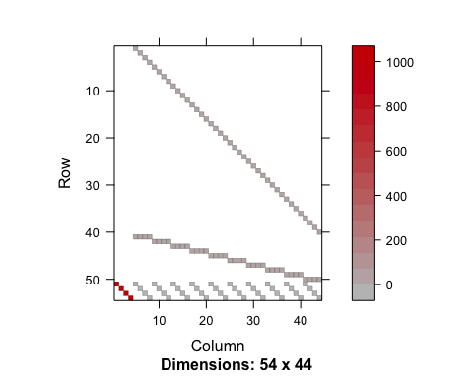

myLP = list()  
myLP$obj = cvec  
myLP$A = Amat  
myLP$sense = dir  
myLP$rhs = bvec  
myLP$vtypes = "B"  
myLP$ub = 1  
  
mysol = gurobi(myLP)

## Warning for adding variables: zero or small (< 1e-13) coefficients, ignored  
## Optimize a model with 54 rows, 44 columns and 124 nonzeros  
## Variable types: 0 continuous, 44 integer (44 binary)  
## Coefficient statistics:  
## Matrix range [1e+00, 1e+03]  
## Objective range [1e+00, 1e+00]  
## Bounds range [1e+00, 1e+00]  
## RHS range [1e+00, 3e+01]  
## Found heuristic solution: objective 4.0000000  
## Presolve removed 50 rows and 40 columns  
## Presolve time: 0.02s  
## Presolved: 4 rows, 4 columns, 9 nonzeros  
## Variable types: 0 continuous, 4 integer (4 binary)  
##   
## Root relaxation: objective 1.666667e+00, 4 iterations, 0.01 seconds  
##   
## Nodes | Current Node | Objective Bounds | Work  
## Expl Unexpl | Obj Depth IntInf | Incumbent BestBd Gap | It/Node Time  
##   
## 0 0 1.66667 0 4 4.00000 1.66667 58.3% - 0s  
## H 0 0 2.0000000 1.66667 16.7% - 0s  
##   
## Explored 1 nodes (4 simplex iterations) in 0.05 seconds  
## Thread count was 4 (of 4 available processors)  
##   
## Solution count 2: 2 4   
##   
## Optimal solution found (tolerance 1.00e-04)  
## Best objective 2.000000000000e+00, best bound 2.000000000000e+00, gap 0.0000%

mysol$objval

## [1] 2

mysol$x

## [1] 1 1 0 0 1 0 0 0 1 1 0 0 1 1 0 0 1 1 0 0 1 1 0 0 1 0 0 0 0 1 0 0 1 1 0  
## [36] 0 1 1 0 0 1 0 0 0